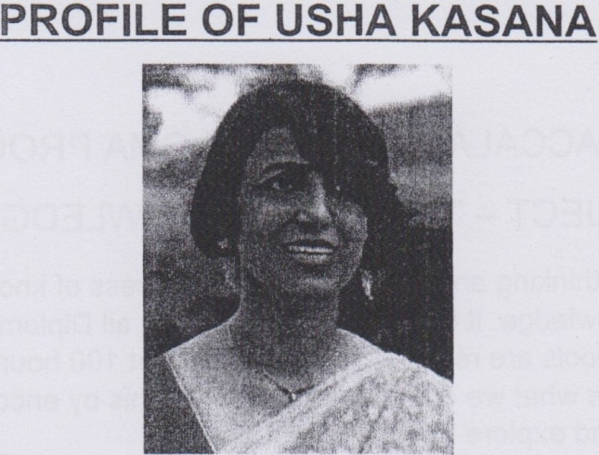

Ms. Usha Kasana from India is currently working at Aga Khan School Dhaka as an IB-DP Coordinator. She has over 26 years of teaching experience, and has worked with renowned institutions like NIIT (National Institute of Information Technology). She has taught Indian and international curricula like Central Board of Secondary Education (CBSE) and International Baccalaureate (IB). She has worked in various positions including as a teacher, head of the department, IB Examiner, TOK Facilitator, and IB-DP Coordinator. She has always been actively involved in Professional Development Programmes for teachers and conducted many workshops in her subject Computer Science and Information Technology in the Global Society and other topics like "Approaches to Teaching and Learning", "Integration of technology in disciplines", "Assessments for Learning", "Vertical and Horizontal Planning in teaching". She has also led different committees like School Philosophy, Curriculum, and Resources in MSA (Middle States Association of Colleges and Schools), CIS (Council of International Schools) and IB-DP.

She holds a masters degree in Computer Science and in Commerce, a Bachelors in Education, and an honours diploma in Systems management from NIIT. In 1994, while working at NIIT, she received the award of excellence in teaching from Dr. Kiran Bedi, the first Indian IPS woman officer.

TOPIC-THEORY OF KNOWLEDGE (TOK)
TOK is a course about critical thinking and inquiring into the process of knowing, rather than about learning a specific body of knowledge. It is a core element which all Diploma Programme participants undertake and to which the institutions are required to devote at least 10 hours of class time. The TOK course examines how we know what we claim to know. It does this by encouraging participants to analyse knowledge claims and explore knowledge questions.
The course encourages participants to think about the nature of knowledge, to reflect on the process of learning in all the subjects they study as part of their Diploma Programme course, and to make connections across them. TOK is one of the three elements of the core (TOK, CAS and the extended essay) introduced by the original curriculum designers of the Diploma Programme as a way to educate the whole person.
TOK encourages participants to consider the contexts and views of others, and ensures that the principles and values developed by participants are reflected upon throughout their life time. This might include, for example: emphasizing different cultural perspectives in TOK and how different cultural traditions have contributed to our current constructions of knowledge.
TOK participants examine thinking in order to understand what constitutes good thinking and also to recognize potential flaws in thought processes. Participants also think about what thinking is required in a variety of situations, as well as how thinking relates to emotional processing and intuition.
The raw material of TOK is knowledge itself. Participants think about how knowledge is arrived at in the various disciplines, what the disciplines have in common and the differences between them. The fundamental question of TOK is "how do we know that?" TOK explores methods of inquiry and tries to establish what it is about these methods that make them effective as knowledge tools. In this sense TOK is concerned with knowing about knowing.
The TOK class room invites a unique partnership of learning, for global controversies often rest on significant knowledge questions that can provide useful starting points for TOK explorations and TOK, in turn, can contribute significantly to the understanding of these large questions. The IB vision of internationally minded individuals implies a global engagement, embodying a commitment to address these 21st century challenges.TOK exists at the very core of the quest, as we strive toward an enlightened and fulfilled humanity.

