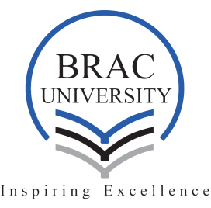
The Department of English and Humanities, BRAC University invites you to a sharing session
Early Childhood Development Programme of BRAC International and its Impact
by
TanzinaQuddus Dina
Manager, Early Childhood Development
BRAC International

Previously Ms. Dina had worked for the Aga Khan Foundation (AKF-B) as an ECD officer. She has an M.Sc. in ECD from BRAC University, prior to which she completed an M.A. in Applied Linguistics and B.A. in English from the Department of English, University of Dhaka.

Programme
Date: 17th February2019 (Sunday)
Time: 3:30-4:30 pm
Venue: Seminar Room UB 21301 (13th floor of University Building 2)
Department of English and Humanities
BRAC University
66, Mohakhali C/A
Dhaka-1212

Your presence will be highly appreciated.

