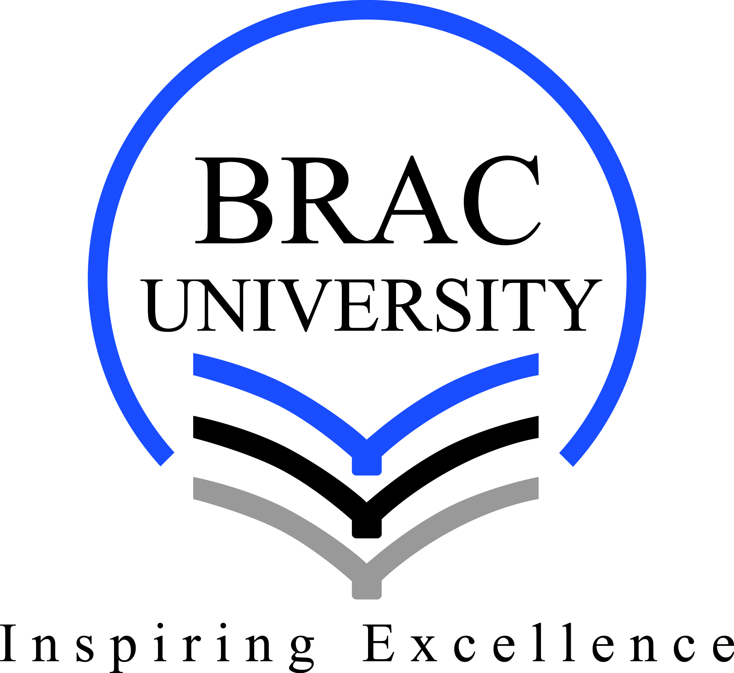
Faculty Search
Department of English and Humanities

BRAC University is the highest ranked private university in Bangladesh according to QS Asian University Rankings. The Department of English and Humanities, BRAC University invites applications for the positions of Assistant Professor and Lecturer. Besides having excellent academic records, candidates should meet the following: requirements:

Position | Qualification | Teaching Experience
Assistant  Professor | PhD | --------------------------------------
 | Bachelor and Masters in English Literature/ ELT/ Applied Linguistics/ History/ Humanities  from a reputed university | Total 5 years of Full-time teaching experience out of which, at least 2 years as a Senior Lecturer.
Lecturer | Bachelor and Masters in English Literature/ ELT/ Applied Linguistics/ History/ Humanities  from a reputed university | Full-time teaching experience is preferred

Application Procedure: Interested candidates meeting the above requirements should apply online through www.bracu.ac.bd/about/get-involved by 3 July 2018. Any attempt to unethically influence the selection process will disqualify the candidate’s application.

Only shortlisted candidates will be contacted.

The Daily Star, 03 November 2017 (3 column, 8 inches)

