BIL Conducts 25th Journal Club Session
Brac Institute of Languages (BIL) arranged the 25th session of Journal Club on March 21, 2019. Ms. Samira Osmany and Mr. Sohan Shahriar, Lecturers at BIL, reviewed Ritu Chandra’s article titled “Classroom Management for Effective Teaching”.
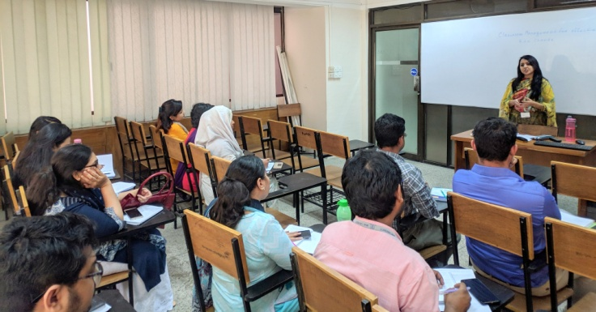
The article discusses different aspects of classroom management including problems faced by the teachers, and techniques or solutions suggested by different researchers. The article acknowledges the major shift in the classroom setting where students are taking a more active position rather than being a passive receiver. Furthermore, the article mentions the problems regarding classroom management such as indiscipline, lack of interest and attention of students. The author suggests that awareness of the classroom dynamics, reinforcement and close student-teacher relationship can help the teachers to overcome the problems.
The presenters regarded the article as an important addition to the knowledge of the teachers. They also initiated a discussion with the participants to find out the reasons why students show indiscipline in classroom. The participants provided various responses such as lack of interest and motivation, tight schedule, early morning or late afternoon classes and so on.
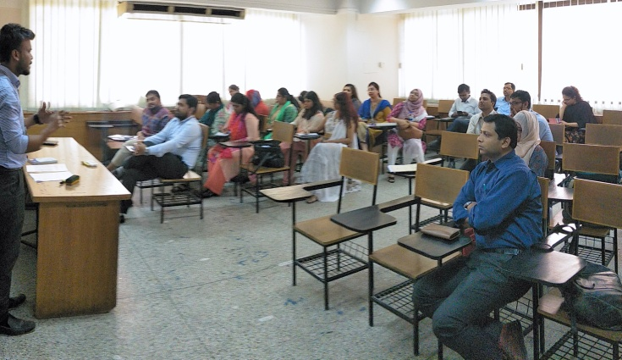
The question-answer session initiated a crucial discussion regarding the actual practice of classroom management techniques. The participants reflected upon whether the techniques mentioned by the author are practised at BIL. Most of them responded that many of these techniques are used by them in language classes at BIL. However, some of them thought that there were still some opportunities to incorporate certain ideas suggested by the article.
BIL Lecturer Becomes Global Ambassador of the Purdue Graduate School, USA
Mr. Md. Shams Ud Duha, Lecturer at BRAC Institute of Languages (BIL), who is currently pursuing his PhD at Purdue University, USA, has been approved as a global ambassador for Purdue’s graduate school. Mr. Duha will promote the university in Bangladesh and other countries as part of this global ambassadorship. He plans to arrive in Bangladesh in October 2019 to conduct sessions at different universities on higher education opportunities at Purdue.

